Calcium chloride (“Calchlorin”) male animal sterilization: Ingredients and procedure

rev. 1 December 2014

What calcium chloride is:
An injectable sterilant for male dogs, cats, goats, rabbits, and other animals. The injection leads to permanent sterility, with onset and testicular shrinkage over the course of about four weeks. Testosterone levels are substantially reduced in a dose-dependent manner, leading to change in some male behaviors. Mating-related behaviors are most likely to be affected (in dogs, mounting/humping, marking/spraying, roaming, and fighting over females), while guarding and breed-specific behaviors are least likely to be affected.

How to order it:
“20% (w/v) Calcium Chloride Dihydrate, USP in Ethyl Alcohol 190 proof, USP”
from a reputable and well-regarded sterile-filling-capable compounding pharmacy (preferably PCAB-accredited in the U.S.), sterile-filled in vials. For rural farm use and use in extremely low-resource settings without access to reputable compounding pharmacies, 20-25 g of powder (about ¾ oz.) is mixed with about 90 mL of pure 190-proof drinking alcohol (about 3 oz.) to make 100 mL of sterilant (about 3.5 oz), then filtered through a 0.2-micron syringe filter; read document to the bottom and see important cautions below.

Note: The following information is background information which may be most helpful to organizations in extremely low-resource settings outside the U.S. that do not have access to reputable compounding pharmacies. If you are a veterinarian or organization planning U.S. use and have already read the extensive background information provided at ParsemusFoundation.org and worked through the due diligence suggestions checklist at Calchlorin.org, the following information, based on usage in published studies from India and Italy, may be more detail than is needed. When in doubt, always refer to the information provided by Spay FIRST! at http://www.spayfirst.org/programs/non-surgical-sterilization/ for the final word on real-world usage technique, based on experience in more than 1,000 dogs.

Its status:
Available worldwide via compounding or mixing from off-the-shelf ingredients, but not FDA-approved. It would take several million dollars to take calcium chloride through the FDA testing and approvals process. So far, no large funder has seen this as a priority, especially since Neutersol/EsterilsolTM injectable sterilant has returned to the U.S. market (as ZeuterinTM) in 2014, providing a commercially-available injectable sterilant for dogs in the U.S. However, sterilization and neuter are not the same; though Zeuterin stops sperm, it does not reduce testosterone to castrate or near-castrate levels and is marketed as not producing behavior change. Furthermore, in most countries other than the U.S., there is no injectable male sterilant option for dogs at all, other than calchlorin, since Zeuterin is not available; and nowhere in the world is there a marketed alternative to surgery for cats.

One small organization, Parsemus Foundation, has been spreading the word about published calcium chloride research to date and funding additional research. However, Parsemus Foundation does not have the scale of funding needed to take Calchlorin through the multi-million-dollar FDA approvals process. Until/unless larger funders step in, this sterilant will never have regulatory approval.

Though there is no commercially-marketed formulation and the data and reassurance that would come from the FDA trials process, veterinarians have considerable discretion in the practice of veterinary medicine and are generally considered to have the option to use compounded treatments when no commercial treatment is available for a particular indication, as long as they keep records, provide follow-up, there is a basis for expected safety in the published literature, and patient welfare is maintained as the foremost concern. The first United States organizations started trying it and then using it in winter 2013/2014, mostly due to the open-mindedness and vision of one visionary organization, Spay FIRST. As word of their highly positive experience spreads, other associated groups are starting to use it as well. As of November 2014, one rescue group, two shelters, and one high-volume clinic are using it, and additional groups trying out calcium chloride will no longer be the first.

This sterilant can be made by a sterile-filling-capable compounding pharmacy quite simply and inexpensively, upon individual veterinarian request, if the veterinarian believes the treatment is likely to produce the greatest good for the animal and community and that the benefits outweigh the risks, based on a careful reading of all available literature. If a veterinarian’s country has a veterinary regulatory authority, the veterinarian and his/her organization should consult with the veterinary regulatory authority and national/state/regional veterinary board regarding requirements for use of compounded products. Whether or not the veterinarian’s country has a veterinary regulatory authority, the veterinarian should seek the participation and support of local officials and thought leaders. For more information, see the regulatory status document on Parsemus Foundation’s calcium chloride web page, http://www.parsemusfoundation.org/calcium-chloride-for-males/ .

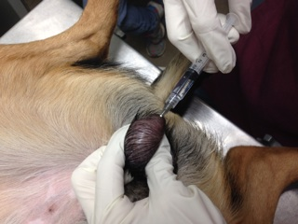
Injection site, U.S. dog use, 4/2014 (courtesy of W.H. and R.S.)

How calcium chloride compares to ZeuterinTM /EsterilsolTM (previously known as Neutersol):
- Regulatory status:
Calcium chloride injection is not FDA approved; Zeuterin™ injection is FDA approved.
- Availability:
Esterilsol/ Zeuterin™ injection is now commercially available in the U.S. since February 2014; calcium chloride in alcohol injection (“Calchlorin”) is available through compounding or self-formulation worldwide.
- Testosterone reduction and behavior change:
When used in alcohol, calcium chloride appears to produce a larger testosterone reduction and more behavior change than Zeuterin/Esterilsol, based on results from Italian studies (Leoci 2014) in mid-size dogs (63-85%). The injection technique being used in U.S. use, through the epdidiymis into the testicle (see above), appears to reduce testosterone even further, to castrate levels, except in the largest dogs.
Esterilsol promotional literature states that Esterilsol does not significantly change behavior, which is an advantage in some situations (e.g. with owner concerns about masculinity, or to retain the health-protective effects of testosterone, such as against bone and blood cancer, which are lost with surgical or chemical castration). In marketing to the U.S. market, the expectations being promoted regarding ZeuterinTM are more equivocal, for example “As with surgical castration, Zeuterin™ may or may not not eliminate male behavior such as roaming, marking, aggression, or mounting in dogs. Anecdotal information collected from dog owners shows that zinc neutering does suppress mating behaviors very much like castration. Formal statistical evidence is not there.” (http://www.arksciences.com/faq.html, accessed 10 June 2013) Yet benefits to Zeuterin are listed as “Avoid anesthesia/surgical procedure and maintain hormone function” (accessed December 1, 2014). Anecdotal reports from the Zeuterin team (M.W.) support only limited behavior change from Esterilsol and indicate that a second Esterilsol/ Zeuterin™ injection, two months after the first, will change behavior; however, a single dose of Esterilsol/ Zeuterin™ large enough to change behavior would be likely to have adverse effects.

Because calcium chloride injection has shown clear reduction of sex-linked behavior in cat and dog studies in India, dog studies in Italy, and recent use in the U.S., and testosterone reduction in hCG-stimulated testosterone tests (the gold standard) in Italy and the U.S., and Zeuterin has shown less and much more variable testosterone reduction in hCG-stimulated tests by the same team in the U.S. (consistent with the on average 41-54% reduction reported in its literature in non-hCG-stim tests), we believe that Esterilsol/ Zeuterin™ is thus appropriate in situations where partial testosterone preservation and little to no behavior change is desired; Calchlorin, or two injections of Esterilsol/Zeuterin™ two months apart, is appropriate when behavior change is desired.

Why behavior change is important:
Data indicate that sterilization of males does not have a population impact except in very specific situations (in general, any remaining unsterilized males will do the job, unless territories are very large). Therefore, much male sterilization is done for community safety purposes (to reduce dog roaming, packing, and fighting) or for adoptability reasons (to reduce male cat spraying and odor).

The background and evidence:
Calcium chloride has been the subject of numerous published studies over the past decades, with key recent publications in cats (Jana 2011) and dogs (Leoci 2014). See the bibliography document, part of the download packet available at Parsemus Foundation’s website, for references.

Important study just published, October 2014:
The first-ever full-year study of calcium chloride dihydrate dog sterilization (conducted in Italy by Leoci and colleagues), published in October 2014, has produced new information:

Alcohol is the most effective base for calcium chloride.

Calcium chloride has been dissolved in three different bases, alcohol, saline, and lidocaine, in past studies. But the latest study, the first to compare the three treatments head-to-head, indicates that alcohol is superior in three ways:

• Quicker onset of action (1 month instead of 2 months to azoospermia)

• Better tolerated (less inflammatory reaction: very little swelling, vs. some swelling the first 3-5 days for saline and lidocaine bases)

• More reliably permanent. Dogs getting calcium chloride dihydrate 20% in all three bases (saline, lidocaine, and alcohol) were all still sterile at 6 months. However, by 1 year, some dogs in the saline-and lidocaine-base groups had regained some sperm production. While their low levels of sperm would probably not be enough to make them fertile, the regeneration of sperm production raises the risk of possible fertility in the future. Please see the full studies (Leoci R, 2014) for more information.

The pure-alcohol formulation is the one which has been shown to be still free of living sperm at 1 year in 100% of dogs, and is now considered best practice. It is referred to here as “Calchlorin” to distinguish it from older formulations.

The cautions:
Calcium chloride sterilant (Calchlorin) has not been through the FDA study and approval process. It may or may not be legally or societally acceptable for use in your context. Consult with veterinary authorities in your area about proper legal procedure and record keeping in your region/country/state. A step-by-step guide to due diligence is at www.Calchlorin.org.

When trying a new procedure, be prepared for a learning curve; though in Italian studies and U.S. dog use no complications have been seen other than initial swelling, you may find skin reactions, or even sterile abscesses that resolve on their own, in some animals at first depending on your technique and ingredients. It is best to try it first on animals that can be monitored, before field/feral use. The testes may be swollen for several days after the injection before starting to shrink. Until you are comfortable with the dose and technique, do not use Calchlorin unless you are prepared to surgically castrate animals if not satisfied with the results or if concerned about the animal’s progress. For a conservative view, see the position statement by the Alliance for Contraception in Cats & Dogs for further cautions. Most of all, when using Calchlorin, follow the specific tips and instructions at SpayFIRST’s non-surgical sterilization page, http://www.spayfirst.org/programs/non-surgical-sterilization/ .

Time of year/season:
If possible, in hot regions, avoid performing injections during the peak of summer heat. It is hypothesized that animals are more susceptible to scrotal swelling in the first days post-injection if they are unable to find cool places to lie. Scrotal swelling was not seen in dogs injected with the alcohol formulation in the 2012 study in Italy, but scrotal swelling and one abscess were seen in three dogs injected in Asia in midsummer (July) 2013. Though this is just a hypothesis, and other variations in technique (such as the reported use of iodine and alcohol scrub during testicular prep) could explain the results in Asia, use during non-peak-heat season is likely to be more comfortable for both animals and animal health workers in any case.

Prepping the scrotum:

To avoid irritating the scrotum, only trim the fur if necessary; do not closely shave.

To clean the area, use non-irritating antiseptics: sodium hypochlorite solution, or very dilute chlorhexidine (one to two tablespoons per gallon)— not alcohol, hydrogen peroxide, or iodine.

We hear from colleagues in high-volume spay/neuter that using non-irritating antiseptics when cleaning the scrotum is essential to avoid increased urge for the animals to lick. One U.S.-based organization reports that when they banned iodine and alcohol cleansers from their spay/neuter surgery suite, their post-surgical adverse reactions fell from about 1 in 20 to 1 in 1000. Although that is for full surgery, this experience is worth keeping in mind for injection preparation as well.

Always refer to the instruction sheet downloadable at SpayFIRST.org’s non-surgical sterilization page for the final word on tips on technique, as they are based on successful experience in over a thousand dogs.

Injection procedure:
The basics: To prepare the syringe (preferably one syringe per side), draw up the solution from the container/vial. It is preferable to then remove the needles and put on fresh needles, although this has not been done in some of the published studies to date, and it appears that wiping any residue may suffice. However, for the price of a needle, it is a worthwhile precaution, and is being done and recommended by SpayFIRST!, the pioneers of U.S. use. Isolate the testicle, pulling the skin taut. Inject the solution from the caudal (tail) end of each testicle, missing the epididymis if you are using the original technique from Indian and Italian studies (although injecting from the other end seems to work fine too), going through the epididymis into the testis if using the U.S technique, which appears to result in even greater testosterone reduction (refer to SpayFirst’s materials, written by the practicing veterinarians, for the final word on technique). Unless you are using a very fine needle such as an insulin needle, expect the animal to vocalize as the needle goes through the skin, especially on the first side (which has the added surprise factor); once the needle is through the skin, the animal should settle down. Then inject slowly (at least 7 seconds per side, preferably 10-20) to avoid creating uncomfortable pressure, depositing the solution at the center of the testicle. If in a very large dog you choose to withdraw the needle gradually while injecting to distribute the solution along more of the length of the testicle, be sure to stop withdrawing while still well within the testicle, to avoid depositing solution outside the testicle between the testicle and the scrotal skin, which could cause skin reactions. Or use the technique used for larger animals in the original 1970’s studies (Koger et al), puncturing the skin once and then moving the needle several times to deposit in multiple locations.

WITHDRAW THE NEEDLE, OR DON’T WITHDRAW, WHILE INJECTING?

INJECTION TECHNIQUE UPDATE, 2013

• The pioneering team in India (Jana/Samanta) is no longer recommending withdrawing the needle slowly while injecting. Their new recommendation is to inject the full dose of calcium chloride at the center of the testis. They propose that this both assures that all areas will be reached as the sterilant perfuses/ works its way outwards; and assures that it stays farther away from the injection site, reducing the chance of skin reactions.

• The team in Italy that conducted a study to independently replicate the studies from India (Leoci et al.) used the leave-in-place injection technique in the videos available, but apparently used the previously-described technique on some dogs as well, slowly withdrawing the needle while injecting to attempt to distribute the sterilant through the testis-- and they did not see abscesses or other skin problems (although, interestingly, ultrasound imaging revealed that despite the effort to distribute the sterilant by injecting while slowly withdrawing the needle, the sterilant formed a bolus anyway).

• It seems that either technique—injecting all the sterilant in the center of the testis, or slowly withdrawing the needle while injecting—is likely to work fine. The one caution is that if slowly withdrawing the needle while injecting, one should be sure to end the injection while still well within the testis (to avoid depositing sterilant in the space between the testis and the scrotum). For either method, one should apply pressure to (pinch) the injection site during and after needle removal, to prevent seepage.

• For animals with testes less than 2 cm across, slowly withdrawing the needle is unlikely to be necessary (the solution is thought to reliably affect tissue at least 1 cm from site of injection), and it is probably better to use the “inject into center” technique and avoid the extra movement of the “withdrawing slowly” technique. For animals with testis dimensions greater than 23 mm, it is not known whether the “withdrawing the needle” technique, or indeed multiple injection points, is necessary for full efficacy. More widespread use should clarify this.

• The highly-successful U.S. use uses the leave-in-place technique and has gotten excellent results for dogs under 75 pounds and acceptable results in dogs over that size (they will be trying the multiple-deposits technique to try to optimize testosterone reduction in the largest dogs).

• Videos of the injection techniques used in Italy and in India are available at the Parsemus Foundation website, http://www.parsemusfoundation.org/calcium-chloride-for-males/ . An instructional video of the SpayFIRST! Injection technique is available at http://www.spayfirst.org/programs/non-surgical-sterilization/ and should always be the final authority.

Use the dosage below as a guide, but if the testis starts feeling extremely full, it is okay to STOP before the full dose, especially if the testis was on the borderline between two doses.

Guideline for dosage per testicle:
Testicular Width Dose per testicle
10-14 mm and sexually mature adult cats 0.25ml (if testis feels overly full, STOP before full dose)
15-18 mm 0.5 mL
19-22 mm 0.8 mL* to 1 mL (inject 0.8 mL, continue to fullness)
23-24 mm 1.0 mL* to 1.5 mL (inject 1 mL, continue to fullness)
25-26 mm 1.5 mL to undetermined** (see technique note below)
27 mm and above undetermined** (see technique note below)
*dosage used in the Italian study

Note from SpayFIRST!: Always pull 0.2 ml of calcium chloride over the maximum recommended dose. Up to 10% of dogs require up to 0.2 ml more calcium chloride in order to achieve a firm feeling upon injection. This includes large and small dogs, as elongation of the testicle may change the required volume significantly.

**Note December 2014: Dosage for large dogs is not determined. The Italian study was of average shelter dogs and did not include particularly large-breed dogs; in SpayFIRST! experience, testosterone reduction in large and giant-breed dogs has not been to castrate levels as it has been with small and medium-large dogs. A technique adjustment such as used by Koger et al. in the 1970's (large-animal studies), inserting the needle once but then moving it to several spots within the testis to leave boluses of fluid distributed throughout the testis, may be necessary for satisfactory testosterone suppression in dogs with large testicles and other large animals.

Wait momentarily for the pressure to equalize. Pinch/hold closed the injection site skin briefly while, and after, withdrawing the needle, to prevent seepage. Unlike with Zeuterin, if any Calchlorin is spilled, it appears that it can simply be wiped off; in studies to date reactions have not resulted afterwards.

Do both testicles. Always start with the same side so there is no forgetting or confusion. Some veterinarians always start with the right side, so that the “left is left,” as a memory tool.

For very large dogs (dogs with testicles larger than the adult dogs in the photos below) and larger animals, dosage is not determined. Koger (1978) reported 2 ml of 30% calcium chloride per testis in an 85-pound Golden Retriever and that “in cattle, results so far indicate that doses of 1.0-2.5 ml per 100 lb. (45 kg) body weight are effective, depending on individual variation.” Recent pilot studies in California in goats (which have very large testes) found 4 mL to be insufficient even after multiple injections; eventually 10mL was used and was effective, though excessive (resulting in skin ulcerations). Dose for smaller animals (e.g. rabbits, rats) has not been determined, although 0.2 mL appears sufficient (and possibly excessive) for rabbits.

Studies in Italy have used light sedation, and current U.S. field users (Spay FIRST! et al.) are using light sedation as well. Sedation is at the veterinarian’s discretion. U.S.-based organizations usually use sedation out of an abundance of caution, as did the Italian study; it makes handling easier and prevents any sudden moves on the part of the dog. Users in India have not used sedation for owned animals or human-friendly animals. For feral animals or cats, sedation will be helpful if budget and recovery conditions permit it, but may not be necessary if skilled staff is available to help with restraint. The sedation-free approach is seen in the video on Parsemus Foundation’s website, showing demonstrations by the Samanta/Jana team in India, which pioneered the modern use of calcium chloride sterilant. The approach has also been used successfully in rural farm use in a low-income region in the United States.

Photos of injection site follow.
From demonstration in India:
Adolescent spotted puppy; black adult dog testis 1 and 2; cat side 1 and 2; and large yellow adult dog. From study in press from Italy:
Large dark-furred adult dog; large white adult dog.

For more examples of testicular injection technique and location, see the videos and information on Parsemus Foundation’s calcium chloride nonsurgical dog & cat sterilization web page. A bibliography of published clinical trials is also available as part of that data collection. This data is all provided for the record, for information on the techniques used in the research studies; for the definitive word based on real-world use in over 1,000 dogs of varying sizes, please watch the video and download the instruction guide at SpayFIRST.org’s website!

Identification
Don’t forget to provide some type of identification that the animal has been sterilized (beyond shrinkage of testicles). Recent work in the US has provided information on rapid subcutaneous injection of tattoo ink near the scrotum as a permanent marker of sterilization. While this mark cannot be seen from a distance, it will allow practitioners to know that the animal has been sterilized so as not to undergo a procedure again. For more information on options for marking animals, see the Parsemus Foundation website animal marking/ID page.

This is an experimental procedure; experimentation is at one’s own risk and responsibility and should be done only with sterile solution and after acquiring all information about risks and regulatory status. Parsemus Foundation is not recommending use of this experimental sterilant in any particular context, only providing the data to date—to the best of our understanding—so that animal welfare groups and veterinarians can make an informed decision about whether it is appropriate for their patients and community.
(photos follow)

adolescent puppy, India (testicular, not U.S. trans-epididymal, technique)
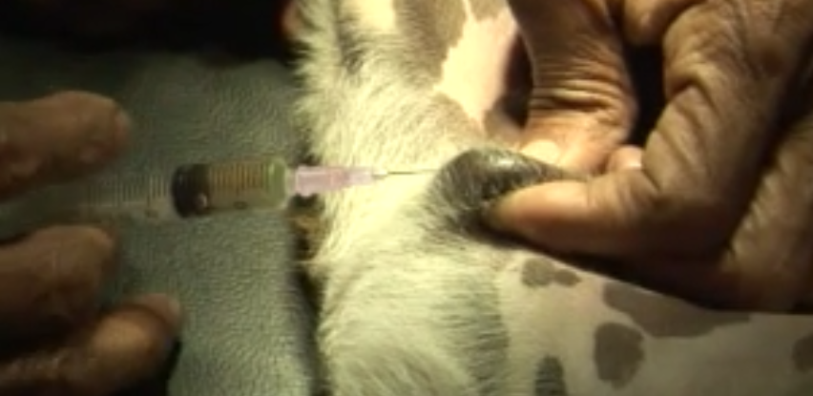
adult dog, about 55 pounds (25 kilos) (testicular, not U.S. trans-epididymal, technique)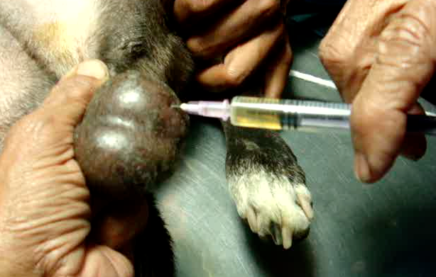
adult cat, India, 2010 (testicular, not U.S. trans-epididymal, technique)
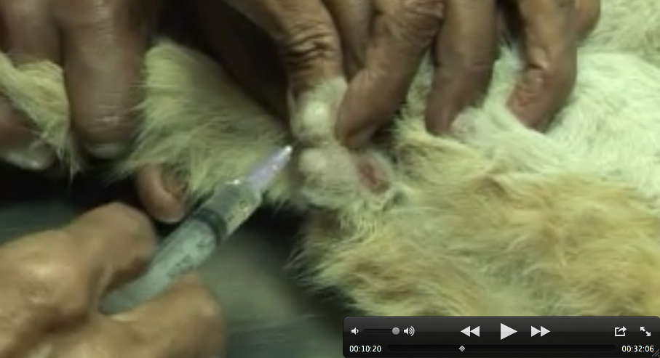

adult cat, side 2 (testicular, not U.S. trans-epididymal, technique)
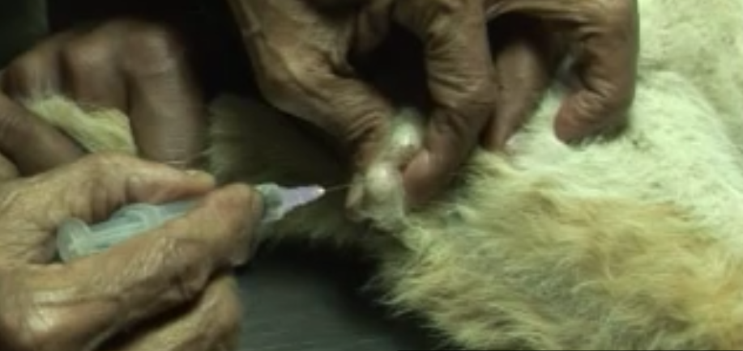

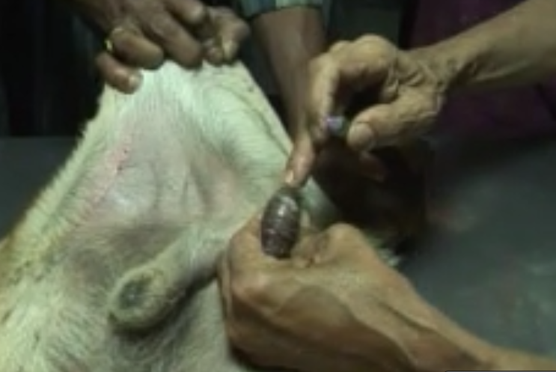
large adult dog (testicular, not U.S. trans-epididymal, technique)
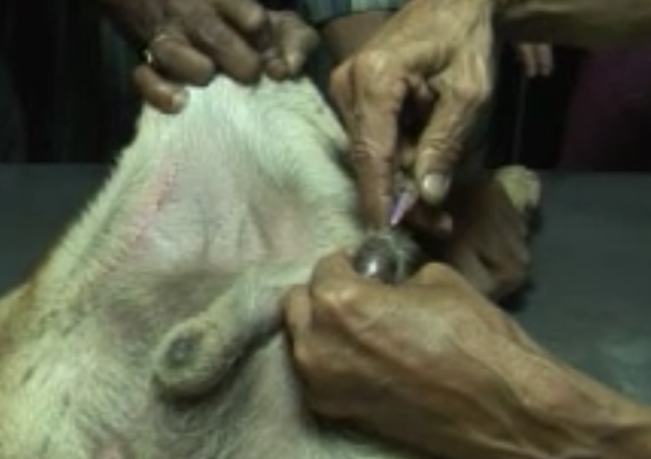

Leoci et al., 2014, Italy: large dark-furred adult dog, 2011/2012 (testicular, not U.S. trans-epididymal, technique)
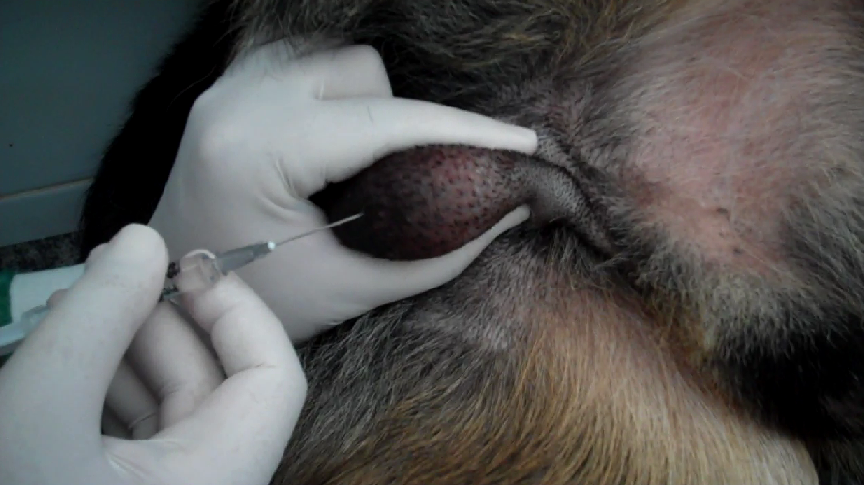

From studies in press (Leoci et al., 2014, Italy): large white adult dog, 2011/2012 (testicular, not U.S. trans-epididymal, technique)
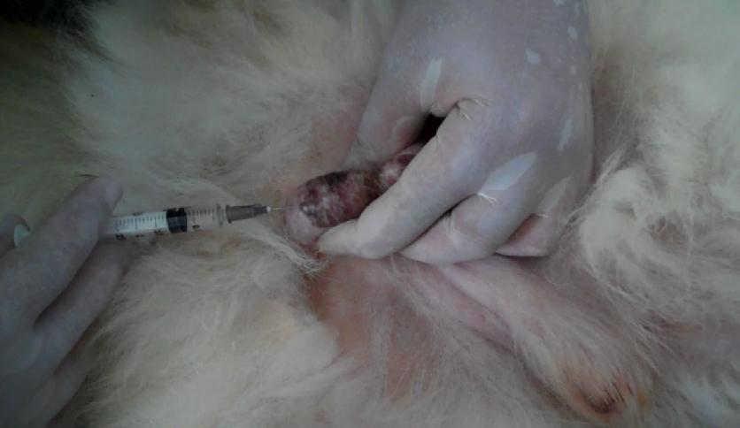

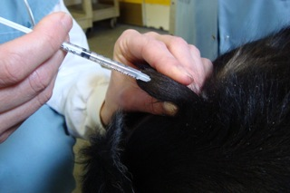
adolescent goat, 2012, USA (testicular technique)

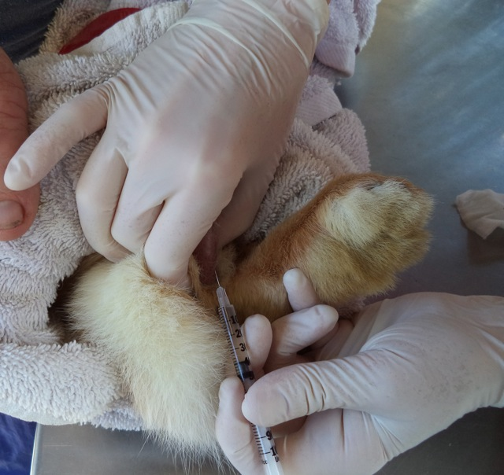
rabbit, 7/2014, USA

If you are in a low-resource setting/country without access to reliable compounding pharmacies:

Note: For veterinary use in the U.S. and other countries with reputable compounding pharmacies, please ignore all the following information; in your case “20% (w/v) Calcium Chloride Dihydrate, USP in Ethyl Alcohol 190 proof, USP” can be ordered from the pharmacy, and proceed directly with the technique instructions at SpayFirst.org!

Supplies checklist in brief for mixing and sterile filling, to inform sterile-filling-capable compounding pharmacy or university contact:

___ calcium chloride dihydrate, pharmaceutical grade (USP)
___ anhydrous 95% (190 proof) alcohol, pharmaceutical grade (USP)
___ scale that measures in grams
___ 50 ml or 100 ml mixing container, plus stirrer
___ clean vials (4mL to 100 mL, depending on your intended volume of use)
___ 0.2 micron syringe filters (and autoclave hood if pre-filling vials rather than immediate use), or
___ autoclave

Most basic supplies for severely resource-limited use without access to compounding pharmacy, laboratory facilities, or the full list of supplies above:
___ aquarium-grade calcium chloride dihydrate (see below)
___ drinking-grade 95% (190 proof) alcohol (see below)
___ scale that measures in grams
___ clean 50 ml or 100 ml mixing container and stirrer
___ 0.2 micron commercially-available syringe filters

Supplies for injection:
___ chlorhexidine 1 oz. per gallon (0.7mL per liter), or sodium hypochlorite solution, for cleaning area
___ 3 mL syringes with 25-gauge or higher needles (must have Luer lock connection if using syringe filters); or 29-guage, ½ inch insulin syringes for small dogs or cats
___ replacement needles

Supplies list in greater detail:

1. Calcium chloride dihydrate powder. Must be dihydrate form, and must be pharmaceutical (USP) grade, not the grade used as road salt for removing road ice. It should be obtained by the pharmacist from a reputable government supply house or chemical supply company, e.g. Sigma, Merck, Fischer, or Applichem. Some examples:
http://www.applichemus.com/calcium-chloride-dihydrate-pure-ph-eur-bp-usp-food-grade-A2979.html
or
http://www.fishersci.com/ecomm/servlet/fsproductdetail?catalogId=-1&productId=757494&langId=-1&storeId=10652&distype=0&isChemical=true&fromSearch=
or
http://www.sigmaaldrich.com/catalog/product/SIAL/12022?lang=en&region=US

We have found Sigma to be fine for existing customers who already order laboratory supplies, but a hassle for new customer signup—and Applichem to have responsive customer service and worldwide distribution that make the process simple. We like Applichem. Merck seems to be the most popular laboratory supplier in Asia for those not obtaining supplies from a central government drug house.

Resource-limited settings: In severely resource-limited or rural farm settings, to replace the painful forms of castration still typically performed without anesthesia, non-pharmaceutical grade but food-grade or aquarium-grade calcium chloride may be the only readily available option. Calcium chloride dihydrate is a salt traditionally used in the food industry, in cheese making and as an anticaking agent, antimicrobial agent, pickling agent, brewing agent, and firming agent. Some users in the U.S. are reported to have used cheese-making calcium chloride solution and boiled off the liquid. Some U.S. users are also reported to have used “Ball Pickle Crisp”-brand additive-free food-grade calcium chloride crystals. Similar additive-free food-grade preparations may be available in other countries. Do not use Ball Pickle Crisp (or presumably other granule-form preparations); it dissolves far less completely, and filters with much more difficulty, than pharmaceutical-grade powder, making it difficult to determine the final strength of the preparation. Calcium chloride is also used for maintenance of saltwater aquarium water balance, and some aquarium sources claim to provide pharmaceutical-grade material. For example, the crystals available online from Bulk Reef Supply dissolve much more readily and completely than pickling granules, appearing similar in behavior to powder obtained from a pharmaceutical supplier such as Applichem. However, the purity of aquarium and food-grade preparations is not guaranteed (for example, see http://www.advancedaquarist.com/2004/3/chemistry for a comparison of purity of brands of CaCl2 sold for saltwater aquariums). Because some of the reputable laboratory supply companies listed above will ship to veterinarians or individuals in nearly any country in the world, and local/regional USP scientific sources exist as well, the USP versions should be used when at all possible.

To learn more about calcium chloride and its various uses, see http://www.answers.com/topic/calcium-chloride .

2. 190-proof ethanol alcohol, USP, contains not less than 94% by volume ethanol (ethyl acohol). Caution: DO NOT USE RUBBING ALCOHOL (isopropyl alcohol) OR METHYL ALCOHOL or laboratory/reagent denatured alcohol. Isopropyl alcohol and other cleaning alcohols have toxins added to them to prevent people from drinking them. Pharmaceutical grade alcohol is best for safety and should be obtainable by veterinarians working on the project. Examples of sources: http://www.fishersci.com/ecomm/servlet/fsproductdetail_10652_5706568__-1_0 or http://www.sigmaaldrich.com/catalog/product/sial/493538?lang=en&region=US or https://us.vwr.com/store/catalog/product.jsp?product_id=7651528

- We expect that even more highly refined alcohol (Dehydrated Alcohol Injection, USP, not less than 98% by volume of ethanol, e.g. http://www.akorn.com/prod_detail.php?ndc=17478-503-05 and http://www.americanregent.com/allproducts.aspx?ProductID=14 ) may work just as well, but 95% anhydrous alcohol USP is the grade that has been used successfully in the recent 2012 dog study in Italy. Dehydrated Alcohol Injection also comes only in smaller vials and is likely to be considerably more expensive (about $47 per 5mL, versus 50 cents per 5 mL). It is not necessary.

- In farm, private, or extremely low-resource settings without access to reputable pharmaceutical suppliers, food-grade alcohol may be acceptable. It must be food-grade alcohol appropriate for drinking/ for making cocktails. For example, in Poland 96% grain alcohol is called “spirytus rektyfikowany”/“rectified spirit;” in Canada the brand “Alcool Global 94%” is available at SAQ stores; in China it may be called “extra neutral alcohol”; in India “Alcohol (95%) I.P.” may need to be obtained from a pharmacist; in Italy it is called “alcool puro” and is used for making the drink limoncello.

Examples of commercially available 96% ethyl alcohols in various countries:

Poland
Bolivia
Italy 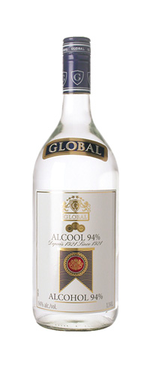 Canada

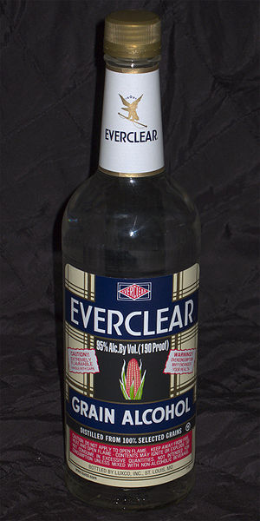 USA or 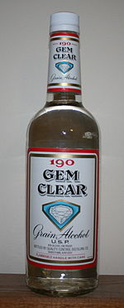 USA

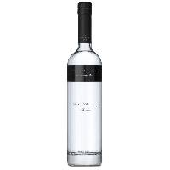 Ukraine Vietnam

Note: Injectable sterilant is most appropriate for use in settings in which psychological constraints limit the acceptance of surgical castration; financial constraints make surgical castration of males cost-prohibitive; or logistical constraints make provision of high-quality and safe surgical conditions and post-surgical care difficult to achieve, putting animals which undergo anesthesia and neuter surgery at some risk.

THIS IS AN EXPERIMENTAL PROCEDURE WHICH, THOUGH THE SUBJECT OF PUBLISHED LITERATURE, HAS NOT GONE THROUGH THE FDA APPROVALS TESTING PROCESS. USE SHOULD BE ONLY UPON FULL UNDERSTANDING OF THE DATA TO DATE, THE RISKS, AND THE VETERINARY REGULATORY ENVIRONMENT IN THE RELEVANT JURISDICTION.

Preparation/formulation

If at all possible, sterilant solution should be properly prepared by a sterile-filling-capable compounding pharmacy. Request the following:

20% (w/v) Calcium chloride dihydrate, USP in Ethyl Alcohol 190 proof, USP.

In countries with corruption and counterfeiting/drug dilution, some spay/neuter organizations or farm users may prefer to make the solution themselves, to know firsthand that they are getting what they expect. Pure (food grade or preferably USP) high-alcohol-content (190 proof) non-denatured alcohol should be used, and calcium chloride dihydrate powder from a reputable supplier (listed above). (Note: Use of lower strengths of alcohol such as vodka, other solvents such as saline or lidocaine, or lower-strength liquid mixtures of calcium chloride in water such as are used for cheese-making are not ideal, may lead to more swelling and pain, are likely to be less effective or permanent, and should be avoided, even in farm or low-resource settings.) Then the mixture should be sterilized through a 2-micron syringe filter (readily available online) or in an autoclave. However, in countries with strong veterinary regulatory authorities and trustworthy pharmacies, getting the solution made in a reputable sterile-filling-capable pharmacy provides more assurance of consistent formulation and sterility and is the preferred option (and only defensible option for veterinarians with compounding pharmacy access).

Compounding and using calcium chloride in alcohol is probably not worthwhile to sterilize four or fewer dogs or ten or fewer cats, as the startup materials and formulation costs will be $50-200. However, for volume use, the cost becomes far less than one dollar per animal. A recent campaign in Nepal reported materials cost of 14 cents per animal, although this has not been confirmed. In the U.S., with a 100 mL vial of solution available for under $50, total costs per animal can be about $1 per dog, including CaCl, mild sedation, needles and syringes, and tattoo ink.

If your pharmacy requests more information, the formulation procedure used in the successful dog study in Italy (Leoci et al.) is as follows:

“The alcohol solution of 20% calcium chloride dihydrate was prepared as follows: 20 g of CaCl₂•2H₂O powder (Sigma Aldrich Corporation) was brought to a final volume of 100 mL of 95% ethanol (Baker Analyzed ACS, JT Baker), mixed, and sterilized in Falcon tubes.”

The formulation procedure used in the successful studies in India was as follows: Calcium chloride dihydrate was combined with solvent, mixed with a magnetic stirrer, run through a 2 micron syringe filter, and filled into vials under a laminar flow hood.

But again, this should be all that most sterile-filling-capable compounding pharmacies need to know:

20% (w/v) Calcium chloride dihydrate, USP in Ethyl Alcohol 190 proof, USP.

More photos of ingredients are available in the PowerPoint videos on Parsemus Foundation’s calcium chloride web page.

We hope that this information has been helpful, and that used judiciously and cautiously, it spares animals surgery and offers organizations the first disruptive technology to address the animal overpopulation and euthanasia problem that is currently leading to the needless loss of millions of animals’ lives per year.

Parsemus Foundation
Committed to innovative and/or neglected medical research, with a focus on
animal sterilants, contraceptive development, and breast cancer. www.ParsemusFoundation.org

(“Veterinary clients' main reasons for not neutering dogs is loss of masculinity. EsterilsolTM does not change the behavior of the male dog. Unlike surgical castration, Esterilsol reduces testosterone by 40-60% on average, and there are no unwanted secondary characteristics of surgical neutering, such as weight gain.” From “Essential Esterilsol,” http://www.arksciences.com/Files/Essential_Esterilsol.pdf , downloaded 6/2014).

